NAME : SOUMIK GHOSH

CSE 21

ROLL : 21052924

OOP LAB ASSIGNMENT 6

1.

#include<iostream>

using namespace std;

class complex{

int real;

int imaginary;

public:

complex(){

real=0;

imaginary=0;

}

complex(int real,int imaginary){

this->real=real;

this->imaginary=imaginary;

}

complex (int real){

this->real=real;

imaginary=0;

}

void display(){

cout<<real<<"+"<<imaginary<<"i"<<endl;

}

~complex(){

cout<<"Destructor called."<<endl;

}

};

int main()

{

cout<<"The complex numbers are : \n";

{

complex c;

c.display();

complex c1(3,5);

c1.display();

complex c2(3);

c2.display();

}

cout<<"The destructor is called 3 times since 3 objects are created .";

return 0;

}

OUTPUT :

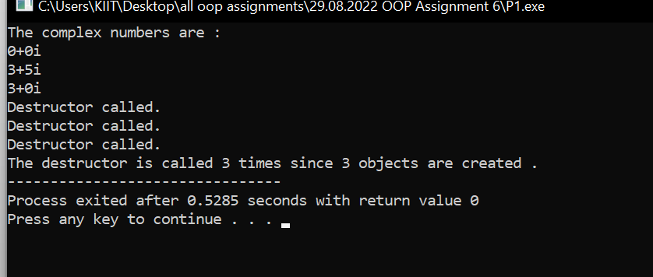

2.

#include<iostream>

using namespace std;

class Time{

int hh;

int mm;

public:

Time(){

hh=0;

mm=0;

}

Time(int hours,int minutes){

this->hh=hours;

this->mm=minutes;

}

Time(int hours){

this->hh=hours;

mm=0;

}

void display(){

cout<<hh<<" hours and "<<mm<<" minutes."<<endl;

}

~Time(){

}

};

int main()

{

cout<<"The timings are : \n";

{

Time t1;

t1.display();

Time t2(2,7);

t2.display();

Time t3(9);

t3.display();

}

return 0;

}

OUTPUT :

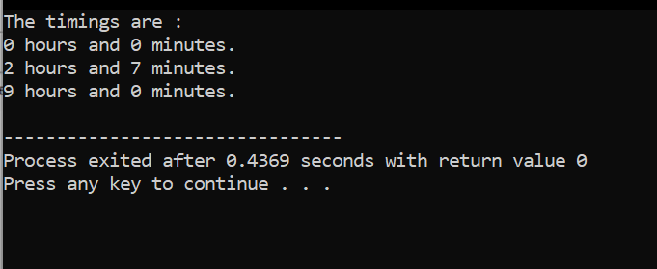

4.

#include <iostream>

using namespace std;

class A

{

public:

A()

{

cout << "Within 1st class." << endl;

}

};

class B : public A

{

public:

B()

{

cout << "Within 2nd class" << endl;

}

};

int main() {

B b;

return 0;

}

OUTPUT :

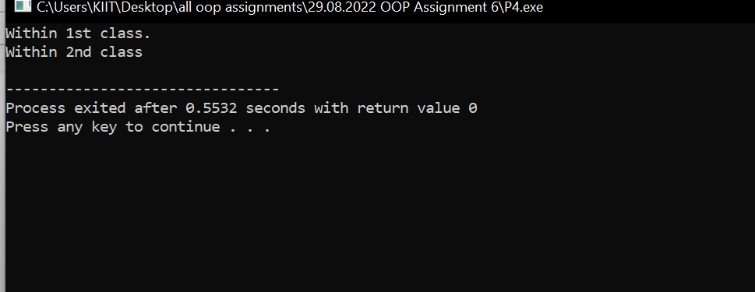

3.

#include<iostream>

using namespace std;

class strings{

string A;

int len;

public :

strings (string A){

this->A=A;

this->len=len;

}

void display(){

cout<<A<<endl;

}

friend void con(strings A1,strings A2);

};

void con(strings A1,strings A2){

string A3;

A3=A1.A+A2.A;

cout<<A3<<endl;

}

int main()

{

string s1,s2;

cout<<"Enter String 1and String 2:";

cin>>s1>>s2;

strings n(s1);

strings n2(s2);

con(n,n2);

return 0;

}

OUTPUT :

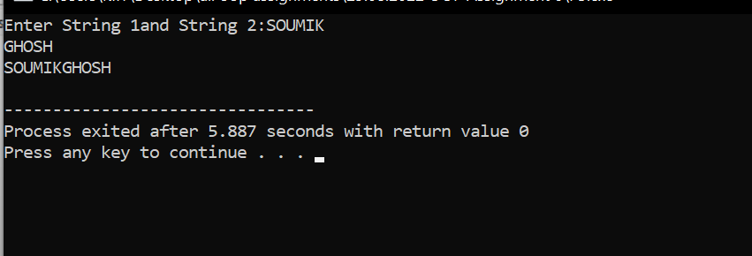

5/A -

#include<iostream>

using namespace std;

class A{

char ch;

public:

// A(A &o1){

// ch =new char [100];

// ch=(o1.ch);

// }

void getdata(char c){

ch=c;

}

void show(){

cout<<ch;

}

};

int main()

{

A a;

char str='S';

a.getdata(str);

a.show();

A b=a;

cout<<endl;

b.show();

return 0;

}

OUTPUT :

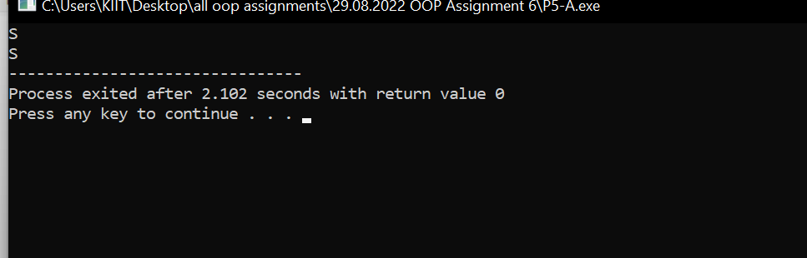

5/B -

#include<iostream>

using namespace std;

class A{

char \*ch;

public:

A(){

ch=new char [100];

}

A(A &o1){

ch =new char [100];

ch=(o1.ch);

}

void getdata(char \*c){

\*ch=\*c;

}

void show(){

cout<<\*ch;

}

};

int main()

{

A a;

char str[]="OOP";

a.getdata(str);

a.show();

A b=a;

cout<<endl;

b.show();

return 0;

}

OUTPUT :

